cid:image002.png@01CDA538.29770530

**United Nations Development Programme Iraq**

**UNDP-Shell Partnership**

**2012 & 2013 Progress Report**

**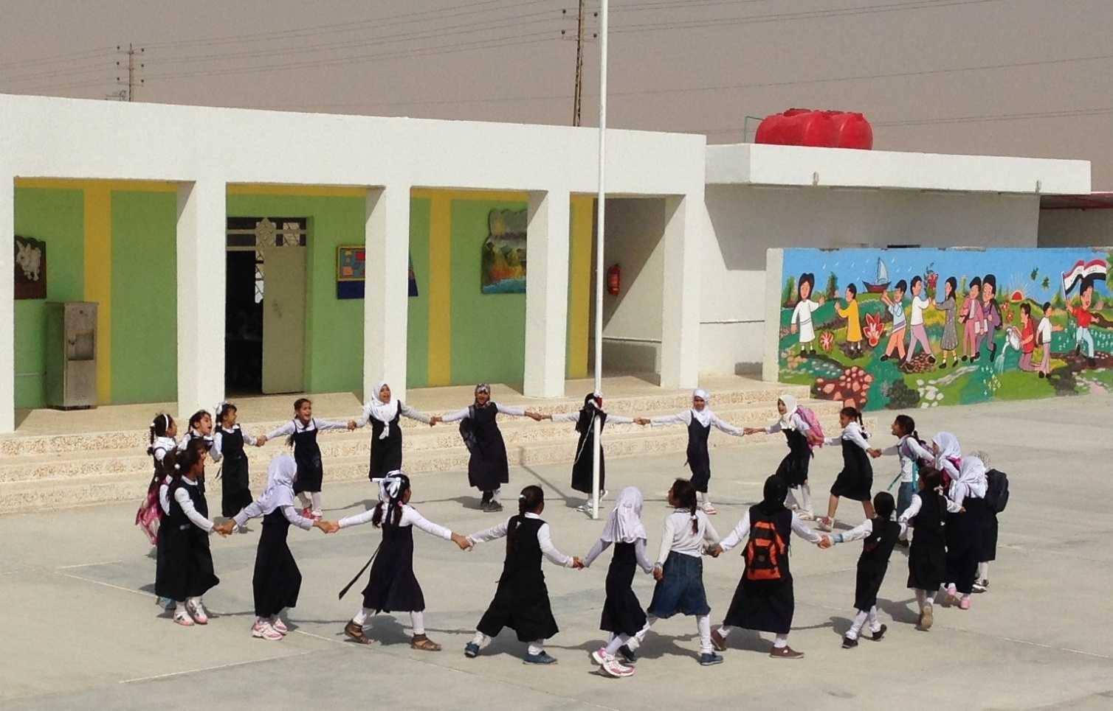**

Table of Contents

[1. Background 2](#_Toc388267416)

[LADP Background & Situational Analysis 3](#_Toc388267417)

[VT/MSME Background & Situational Analysis 4](#_Toc388267418)

[2. Scope of the Programme 4](#_Toc388267419)

[Local Area Development Project for Majnoon Communities (LADP) 5](#_Toc388267420)

[Vocational Training/Micro Small and Medium Enterprises 8](#_Toc388267421)

[3. Project Achievements 11](#_Toc388267422)

[LADP 11](#_Toc388267423)

[VT/MSME 14](#_Toc388267424)

[4. Challenges& Lessons Learned 23](#_Toc388267425)

[Challenges of the Shell-UNDP Partnership 23](#_Toc388267426)

[Operational Challenges 23](#_Toc388267427)

[LADP Challenges 23](#_Toc388267428)

[VT/MSME Challenges 24](#_Toc388267429)

[5. Financial Section 26](#_Toc388267430)

[LADP Financial Summary 26](#_Toc388267431)

[VT/MSME Financial Summary 28](#_Toc388267432)

[Welding Training and Test Centre Financial Summary 29](#_Toc388267433)

[Annex A – Priority Needs List 30](#_Toc388267434)

[Empty Form 30](#_Toc388267435)

[Complete Form 31](#_Toc388267436)

[Annex B 32](#_Toc388267437)

[Hand-drawn Village Map 32](#_Toc388267438)

[Annex C 33](#_Toc388267439)

[Needs and Priorities Identified in Participatory Process (by village) 33](#_Toc388267440)

# Background

In line with both the United Nations Development Assistance Framework (UNDAF) to the Government of Iraq, and in accordance with the contract awarded to Shell by the Government of Iraq to exclusively carry out exploration, development and production of oil and gas resources in southern Iraq, UNDP and Shell entered into a strategic partnership.

To this end, on 20th December 2011, Shell and the UNDP signed a Memorandum of Understanding (MoU) focusing on the following areas of cooperation:

1. Increasing the number of local area development activities in the Majnoon area, and wider Basrah Province;
2. Promotion of local business development activities aiming to build the capacity of MSME’s**,** including supporting training centres in Basrah City jointly with the local authorities in order to strengthen the private sector in diverse local industries.

A programme concept was developed jointly to address both of these issues, and on 13th March 2012, Shell and UNDP signed two Cost Sharing Agreements of a total value of USD 2.5 million, one for the Local Area Development Programme (LADP) and one for Vocational Training/Micro, Small Medium Enterprise (VT/MSME).

The success of the Shell/UNDP partnership has been possible because it serves the different but complementary strategic objectives of both organizations. Shell has a strategic objective to maintain a license to operate in Iraq and to mitigate non-technical risks to their operations. The nature of oil and gas extraction operations exposes the company to a wide range of health, safety, security and environment risks as well as risks from social instability. In the company’s own assessment “*Our success in business depends on our ability to meet a range of environmental and social challenges. We must show we can operate safely and manage the effect our activities can have on neighbouring communities and society as a whole. If we fail to do this, we may incur liabilities or sanctions, lose opportunities to do business, our reputation as a company may be harmed, and our licence to operate may be impacted*”[[1]](#footnote-1).

UNDP explicitly recognizes that the private sector is key to combating poverty by driving economic growth that creates jobs, and supports entrepreneurship, public revenues, and the provision of necessary products and services. The private sector therefore represents one of the key stakeholders in Iraq’s development and a significant source of untapped funding for UNDP Iraq. UNDP’s motivation to partner with Shell has been to achieve the intended outcomes/results of the Country Programme, particularly the eradication of poverty and significant reduction of inequalities and exclusion through the promotion of inclusive growth and indigenous private sector development. In addition, the utilization of a human-rights based empowerment agenda that encourages inclusiveness and a democratic process for decision-making on development issues is also specifically intended to support UNDP’s strategic priorities for good governance as a key contributor to stability and prosperity, particularly in fragile and post-conflict states.

### LADP Background & Situational Analysis

*Iraq’s Development Goals challenged by failing basic services*

Iraq’s human settlement is characterized by a high degree of urbanization and failing basic services and most basic conditions in rural areas are worse. It is therefore not surprising that Iraq’s achievement of the Millennium Development Goals (MDGs) continues to be a challenge. The target project locations are particularly underserved, which impacts social development indicators characterized by high male and female illiteracy and significant prevalence of chronic diseases. Despite relatively high economic opportunities, unemployment is rampant and most youth suffer from lack of access to decent job opportunities, creating social instability. The quality of services is affected by poor planning and management capacity, in addition to an underlying lack of adequate infrastructure.

*Limited capacity of public authorities is a key hindrance to development*

Capacity constraints limit the scope of locally elected politicians to deliver improved services and remain effectively accountable to their local constituency. Few Governorates, let alone district authorities, have demonstrated the capacity to disburse funds allocated as an annual development fund. While disbursement levels have improved year by year, the principal reason for low delivery rates is a lack of capacity and limited skills of senior and middle management staff in core functions of: a) planning and managing capital expenditure; b) procurement and asset management; and c) investment and management of services. Lack of capacity is also cited by senior staff in the Ministries in Baghdad as the main reason for not supporting decentralization of service delivery functions to the Governorates and district authorities.

The capacities of the Federal Authorities to effectively plan and manage services in line with local needs and priorities also remain limited. Quick and sustainable improvement in services can only happen with local officials being better capacitated in participatory and inclusive planning and with the appropriate level of technical support being provided by the national ministries. This will in turn require capacities to be built at both national and sub-national levels, with roles and responsibilities clearly demarcated and institutionalized through effective coordination mechanisms.

### VT/MSME Background & Situational Analysis

Public sector employment in Iraq has been on the rise since 2003 and as a result, the numbers of public employees have almost tripled, with the Government employing nearly half of all employed. It is to this effect that the Government of Iraq (GoI), which is no longer able to absorb new job seekers entering the Iraqi labour market each year, made the creation of an enabling environment and strengthening the competitiveness of the private sector as one of the main goals in its 5-year National Development Plan (2010-2014).

Although full-time private employment has fallen, there is a high demand for qualified local manpower that is currently not met. As a result, companies are resorting to importing qualified workers while unemployment rates in Iraq continue to rise.

The anticipated increase in oil production in Iraq, according to the Integrated National Energy Strategy (INES), will further increase the demand for qualified local manpower, not only cope with the market demands but also to raise the industry-wide standards to an international level. Yet, job classification and skills training that meet industry training standards, with certification by an accredited governing body, professional association or industry organization, allowing the worker to demonstrate specialization and competence in their profession, is completely absent in the Iraqi oil and gas sector. Similarly, Iraqi MSME’s are unable to meet oil companies’ and other investors’ demand for goods and services due to inadequate quality and an inability to access value chains.

In support of the government’s efforts to develop skills and expand training capacities necessary to exploit its hydrocarbon resources, the Shell/UNDP partnership aims to focus on modernizing and increasing performance of the vocational training system and enhance local business development services for MSME’s in Basrah, the socioeconomic hub of southern Iraq.

# Scope of the Programme

### Local Area Development Project for Majnoon Communities (LADP)

LADP is designed around a number of key principles that provide the basis for project implementation and supervision, for local innovations, and for the evaluation of the project and its impact.

**Key Principles of LADP**

**Ownership and Institutionalization**

A key success factor in the sustainability of progress achieved through LADP will be the high level of ownership, resulting in a response to local needs and priorities by focusing on strengthening existing Iraqi institutions and processes. LADP aims to ensure institutionalization and sustainability beyond project lifetime through the improvement of local structures and systems.

**Participation and Inclusiveness**

LADP encourages participatory processes and inclusiveness in local development and service delivery. The success of LADP will be closely associated with the quality and strength of participatory and inclusive processes, as well as the extent to which they are embedded into local development mechanisms. LADP makes concerted efforts to ensure inclusivity of all stakeholders, including vulnerable and marginalized groups in local development dynamics. High levels of participation from all beneficiaries in problem identification, planning, implementation, and monitoring and evaluation phases will contribute to robust local development and improvement of service delivery.

**Transparency and Accountability**

An important aspect of local development and cost-effective service delivery is establishing local performance measurement systems, based on transparency and accountability processes, to ensure activities are responsive to people’s priority social and economic needs. Efforts are exerted to encourage local authorities to fully embrace and endorse the values of transparency, participation, accountability and integrity. Awareness of the benefits of these values, and capacity for advocacy, will be created both with and within various levels of government and civil society.

**Gender Equality**

Gender equality mainstreaming, or the effort to ensure local development and access to services, include provisions for both men and women and is systematically promoted throughout the entire implementation of LADP and underlines all initiatives supported by LADP towards greater integration within local institutions and processes. To this end, gender-balanced participatory processes and mechanisms are locally encouraged in the analysis of challenges and constraints to local development and poverty alleviation, identification of the most important priorities and corresponding coping strategies, formulation of local development initiatives, and delivery of essential services. Importantly, the programme also advocates for women’s equal access to public financial resources and decision-making power.

**Protecting the Most Vulnerable**

Local authorities in Basrah Governorate shall commit to acknowledge and address the needs of the most vulnerable and marginalized. To this end, LADP intends to support Basrah Governorate in developing a better understanding of the vulnerable and deprived groups and their respective needs and priorities per each geographic location. Furthermore, LADP supports developing and implementing adapted strategies and programmes, whose primary target beneficiaries are the most vulnerable and deprived fringe of the population. Depending on the existing situation, determined through the findings of local assessments and local views and perceptions, particular emphasis may be given to the following groups: slums dwellers, rural poor, orphans, street children, persons with disabilities, female headed households, elderly, internally displaced persons, returnees and refugees, etc.

**Persons with Disabilities**

In nearly all developing countries, persons with disabilities are often among the most overlooked vulnerable group, particularly because government-delivered services – including those designed for poor and vulnerable groups – sometimes fail to take into account the multiple needs of recipients who may be disabled. These needs range from accessible ramps for the physically disabled, to provisions for the hearing- and sight-impaired. If not accounted for at the inception of planning, over time certain groups could lack access to the very services enhanced and delivered by careful, locally planned development. Cost is also an issue as the cost to make provisions for the disabled is low at the outset, for example, in construction for hospitals, schools, and other service-delivery facilities, but becomes prohibitively high when accessible ramps or disabled-access bathrooms are installed after construction is complete. In addition to the poverty alleviation lens described above, LADP will ensure that planning at the local government level, and oversight by the centre, includes consideration for the disabled. This will have the double effect of ensuring the inclusion of the disabled – a critically vulnerable group in all areas of Iraq – and lowering long-term costs.

**Environmental Sustainability**

There exists a general lack of awareness about broader environmental issues such as national resource management and climate change. Additionally, a lack of capacity at the centre to enforce existing national environment-related regulations for local government, whose capacity to comprehend and apply policies remains limited. To address this, LADP will make sure that local environmental concerns in Basrah Governorate, and districts in which the programme is active, are well incorporated into all activities.

**Capacity Development**

LADP’s approach to capacity development is dedicated to sustainably building the capacity of Iraqi institutions and civil society organizations and developing partnerships for capacity building that enable Iraqi institutions to learn from and adapt best practice to local needs and conditions. In all capacity development efforts, LADP works in close partnership with the GoI to determine locally agreed institutional development objectives and key functions to be improved with clear time-bound measurable target indicators of improvement.

**Outcome 1: Inclusive participatory processes in local area planning and decision making are institutionalized. Local communities are given a key role in influencing development priorities and in turn contribute to further stability and reconciliation.**

This outcome is aimed at assisting the government to codify a process whereby selected representatives from local communities, together with civil society and the private sector, are able to articulate their local development priorities. Communities will monitor the delivery of services and participate in the stewardship of local assets and resources, thereby contributing to increased transparency and accountability. This process ensures representation of interest groups (i.e. farmers and business men) and inclusion of the vulnerable and underserved groups. The focus is to build awareness and participation in local governance. A network of representatives identified within the communities form a platform to raise community concerns and engage in dialogue with all development partners, including the private sector.

**Outcome 2: Institutional capacity and technical capability at national and sub-national level to support local inclusive development and service delivery established.**

This outcome is designed to improve the institutional capacity of national and sub-national governments to partner, plan and manage sustainable development, and to deliver essential services using transparent, participatory, and well coordinated mechanisms. Technical assistance and capacity initiatives under this outcome will be primarily focused on the district and sub-district councils, mayoral offices, municipalities, provincial planning units, and other key line ministries at the provincial and district level. In addition, national ministries with responsibilities for planning and basic service delivery will also be targeted for capacity building and technical assistance to enable them to play a more effective technical support and facilitation role.

The focus of capacity development will be on establishing responsive mechanisms to address priority needs, enhancing performance and public accountability frameworks. Activities under this outcome will also support effective working relationships between major stakeholders, which will assist with the identification and formulation of suitable local area initiatives for poverty reduction, employment creation, improvement of livelihoods, and access to services, as well as reconciliation and conflict mitigation. Foreseen areas of capacity development will include participatory techniques, monitoring and evaluation, quality assurance, project cycle management and planning, budget execution, communications etc.

The LADP Process Cycle

The process of identifying priorities with multi stakeholder participation is designed to be completed in approximately 4 months and result in a list of agreed priorities.

**1. Sub-District and District Socio-economic development planning**

This step is of utmost importance in giving Technical Departments the opportunity to open a dialogue with communities. The outputs from the consultations will feed into the identification of the most important development projects in each sector to be included in the District Development Plan.

* Conduct in-depth community/area based needs assessments
* Environmental assessments on specific issues raised in consultations.
* Sub-District participatory consolidation of needs and priorities
* Thematic discussions on key cross-cutting issues (poverty, environment, employment, etc.) at both Governorate and District levels

**2. Consultations with Governorate-level key stakeholders**

During this step a list of priority projects are further refined that will potentially offer the opportunity for Shell and other development partners to identify specific projects to be funded by them.

* Discuss projects already being financed with Technical Departments and other potential donors

**3. Decision made by Project Steering Committees on preliminary list of project ideas**

* Present District Plans to Steering Committee and agree on initial list of projects to be financed by Shell and/or other sources

Promising project ideas will be given the go ahead for appraisal and further detailed development.

Proposed criteria for pre-selection will include the following:

1. Projects benefit communities in need, not single individuals
2. Projects address communities’ most important needs and priorities
3. Projects are relevant
4. Projects are feasible
5. Projects are encouraged to contribute to employment generation
6. Projects are sustainable
7. Projects are subject to high local interest and based on local consensus
8. Communities are involved in the management of implementation and are supportive
9. Projects have a positive impact on marginalized and vulnerable groups
10. Projects are sensitive to environmental impacts
11. Projects are economically and/or socially productive investments, not a giveaway
12. Projects that are public/community-private-government joint initiatives
13. Projects that can demonstrate in-kind or in-cash contributions from GoI/communities/private sector
14. Projects that enhance local synergies and partnerships

**4. Appraisal of Sub-Project Ideas and Feasibility Studies**

The preliminary list of approved projects will undergo rapid assessments to identify socio-economic and environmental impacts. Additional rounds of consultation with key stakeholders will ensure adequacy of designs and responsiveness to the needs.

* Prepare project documents/proposals, feasibility studies and budgets, relevant approvals from Technical Departments, and on-the-job-training.
* Prepare M&E framework
* Prepare detailed proposed modalities for procuring goods and/or services, hiring implementing agents.

**Beneficiaries**

Following the signing of the contract awarded to Shell by the GoI to exclusively carry out exploration, development and production of oil and gas resources in the Majnoon Field area, Shell commissioned an impact assessment that identified a number of villages in proximity to the Majnoon site that were deemed as impacted and were to be considered as top priority by Shell for inclusion in their community development programme.

UNDP advocated for enlarging the group of villages eligible to receive programme support based on two main reasons: 1) it would be difficult to explain to the communities why UNDP and Shell would work in some communities and not in others despite close proximity to each other 2) UNDP planned to implement a local planning process intended to be connected with local public budgeting and planning processes. To that end, it was recommended to consider a geographic area that corresponded to institutional or administrative boundaries (district, sub-district, municipality…etc.) in order for the process to acquire institutional ownership and opportunities for government funding. In this instance, the closest administrative entities comprising impacted villages in close proximity to the Shell-operated Majnoon oil field were the sub-districts of Al Nashwah and Al Dair. It was at this point that all of the villages in Al Nashwah and Al Dair were identified as beneficiaries of the community development programme aiming to improve access to quality essential service delivery, and livelihood opportunities and diversification.

Within the communities, UNDP retained the organization’s special interest in a human rights based approach that safeguards access to equitable and essential services for all citizens and to provide a space for all stakeholders, including vulnerable and marginalized groups to voice their views and priorities, and participate in local development decision making. Gender-balanced participatory processes are also encouraged in the analysis of challenges and constraints to local development and poverty alleviation and in formulating local development initiatives and delivery of essential services. The programme is also advocating for women’s equal access to public financial resources and decision-making power.

### Vocational Training/Micro Small and Medium Enterprises

**Output 1: Enabled Vocational Training environment, including programmes and delivery institution(s), meeting the demand for high quality, relevant, timely, cost effective and skilled labour force in all professional craft areas in the Basrah Region**

The Integrated National Energy Strategy defines the vision and mission of the whole energy sector, including oil & gas, power, and linked industries, and highlights the cross-industry dependencies, as well as environmental and socio economic considerations. However, meeting the short term strategies, goals and objectives of the strategy requires the availability of a sufficient and qualified local labour force.

To date, there has been no comprehensive technical assessment of the actual capabilities of the work force in Iraq at the upstream or downstream levels in the oil and gas, power, or linked industries. All training and initiatives conducted to date by various stakeholders in the industry have been undertaken on a circumstantial basis.

The goal of the Vocational Training component of this project is to produce a well-trained, skilled, and competent workforce with the capacity to meet the labour demand in the Basrah region by offering training programmes that are of high quality, relevant, timely, cost effective and skill-based, in all professional craft areas. In parallel, assistance rendered to relevant federal and local authorities to enhance the regulatory environment for licensing and certification of training standards is also included.

Based on an annual training needs assessments, the Vocational Training component of this project will aim to match the demand of the labour market in Basrah with enhanced capabilities of the supplied local labour force by upgrading standards of programmes in existing vocational training facilities related to selected craft skills, and by establishing a new vocational training facility in partnership with local authorities and other stakeholders. In parallel, the introduction of a standard-based licensing and certification system for vocational training will considerably improve the quality of skills and employability of vocational training graduates. The project aims to complete the process for standard-based certification for vocational training in construction.

The labour force training activities of the project aim to meet the following objectives:

* Conduct training needs assessment for IOCs and other Foreign Direct Investors in Basrah
* Design and secure endorsement of a licensing and certification system for vocational training in Iraq, with emphasis on selected craft skills required in the oil and gas industry
* Rehabilitate selected vocational training facilities and upgrade capacities in Basrah in partnership with relevant line ministries (Ministry of Labor and Social Affairs, Ministry of Oil) and local authorities
* Design and establish a pilot vocational training facility to deliver training packages at modern standards and in response to Basrah labour market needs and secure a multi-year cooperation framework for operational and financial sustainability

The actions to be undertaken by the pilot Vocational Training Centre will accomplish several benefits, including:

* Promote the model of a multi-partner vocational training scheme that could be replicated by the local and federal authorities to increase efficiency and relevance for training programmes delivered
* Introduce concepts of multi-year training strategies and budgeting for sustainable training delivery and increased employability
* Enhance local vocational training capacities by introducing new training packages in anticipation of new jobs to be created by incoming capital flows in Basrah
* Address immediate skills gaps in key economic sectors in Basrah
* Deliver expert assistance with a fresh approach for innovation
* Institutionalize regular upgrading skills programmes for employed labour force
* Ensure high levels of labour standards and labour protection, including health & safety standards

**Output 2: Enhanced local Micro-Small and Medium Enterprises (MSME) capacity in Basrah – *Business Support Service Centre: from incubation to inclusive business models***

Micro, Small and Medium-sized Enterprises (MSMEs) are considered to be one of the principal driving forces in economic development. MSME’s in transition countries stimulate private ownership and entrepreneurial skills while rapidly generating employment and helping economic diversification and market-based adjustment, all crucial requirements for sustainable economic restructuring and for limited social impact of reforms.

In addition, MSMEs are the segment of the national economy closer to local communities, which gives them an important role to play in contributing to community development through their close ties with employees, customers and business partners, and by ‘going the last mile’ to supply to and/or to source from a low-income community.

Promoting entrepreneurship has a vital role to play in improving competitiveness of small businesses in Iraq. Business support services are effective instruments for assisting entrepreneurs in starting and developing a new business. These include both incubation services for business start-up, to nurture young enterprise and help them to survive during the initial period when they are most vulnerable, as well as business development and services, to help small companies already launched to develop their activities in order to build partnerships and be integrated in sustainable supply chains and inclusive markets.

The project will aim to offer a strategy for enabling MSMEs in the Basrah region to become agents of growth from the incubation/start-up stage to the business development stage, through a physical centre staffed with trained personnel and leveraging on existing programmes and experiences of a) Shell, in working with local companies in Basrah where business linkages are already established in a number of sectors, and b) UNDP, with established partnerships with Basrah authorities and the private sector, and at the same time with vast experience on global scale in launching and promoting inclusive business models.

The emphasis will be local development and job creation. With this purpose, the project will ensure:

1. The business support scope and strategy is in place (market assessment and gap analysis to identify supply and demand needs against standards according to international/sector base standards, with priority to the oil and gas Industry and identification of key partners)
2. Business support premises are being provided on a sustainable basis to MSMEs (physical infrastructure such as office and/or workshop space on an affordable basis, taking existing institutions and potential partnerships into consideration)

Local institutions (e.g. the Basrah Investment Commission) involved in supporting the linkages between MSME suppliers and large buyers will promote a sustainable development model that will enhance private sector-led growth and create a social environment more conducive to stability and cohesion. The “building markets from below” model in Basrah may be a more effective recovery approach by creating space for the private sector to contribute to development and bring untapped human resources and their labour and economic potential into the value chains.

# Project Achievements

### LADP

UNDP achieved the implementation of a comprehensive participatory planning process in Al-Nashwah sub-district and established mechanisms to identify community priority needs in Year 1 of the project. This process generated project ideas that were derived from genuine consultation and generated activities based on community needs.

The initial stages of implementation required UNDP to establish a cooperative operational arrangement derived from joint decision making on project directions and activities. This included the formation of Village Development Committees (VDC), Sub-District Development Committees (SDDC), Governorate Steering Committee (GCC) and the Project Board (PB). Village representatives from each of the 21 villages in Al Nashwah were elected in May and June 2012 to establish a sub-district village representative network.

UNDP engaged key stakeholders in thematic discussions on key cross-cutting issues (poverty, environment, employment etc.), which resulted in the Identification of root causes of key issues, and developed proposed strategies and innovative projects to be incorporated in the Al Nashwah Draft District Plan, which included a preliminary list of projects that could be financed by the Government and from which Shell could identify interventions to be proposed for implementation under the Shell/UNDP partnership.

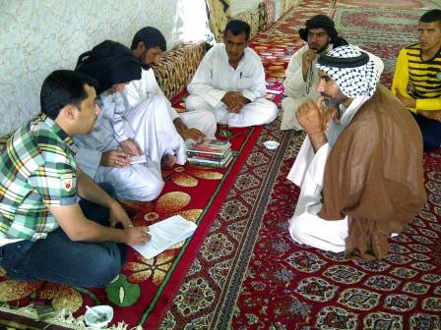 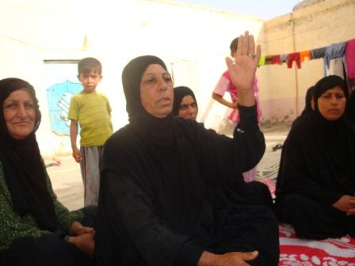

The collection of information on key sectors included the completion of baseline data collection and mapping of existing services, and preparing a Target Area Profile that identified and mapped stakeholders, CSOs, schools and other services etc., which was uploaded on the project website.

Further, the project developed a school planning tool for prioritization of most needed interventions based on spatial analysis, catchment areas, students/classrooms ratio, girls access to school, student/teacher ratio etc.

Based on analysis of data collected, project selection criteria was developed to determine and address communities’ most important needs and priorities that were MDG-based (Environmentally sustainable, gender equality, Employment Generation, Poverty alleviation etc.), subject to high local interest and based on local consensus, and economically and/or socially productive investments (i.e. not a giveaway).

UNDP also engaged in discussion with Technical Directorates, such as the Department of Education and the Department of Health (two sectors identified by both the communities and Shell as priority intervention areas) and other potential donors and produced a list of projects already financed by the GoI and other sources, which led to a revision of the list of projects that could be financed by Shell and supported by the UNDP/Shell partnership.

As a result of the completion of community consultations, feasibility studies, project documents, proposals, designs, and estimated costs were completed in consultation with relevant Technical Departments with relevant stakeholder’s approval. The proposals of various projects aimed to address identified priorities were presented to the Governorate Steering Committee for endorsement and to Shell for funding approval.

The process identified 14 initial project ideas and formulated project proposals for Shell funding under Year-1 and Year-2 (after April 2013).The proposed projects included interventions identified in the following priority areas:

* + - Infrastructure (2)
    - Education (3)
    - Water & sanitation (1)
    - Electricity (3)
    - Agriculture (1)
    - Environment (1)
    - Youth (1)
    - Economic Recovery and Livelihood Revival in Al Nashwah sub-district

Upon approval of a final list of projects, execution modalities and M&E frameworks were established, implementing partners were contracted and resources were mobilized to begin project implementation of the selected projects, of which UNDP assured the quality and measured and reported on progress.

**Education**

In response to priorities identified in the education sector, UNDP and Shell used agreed upon selection criteria to determine two schools in Al Nashwah that were most in need of rehabilitation. Al Ma’Arifa School and Ala Al-Deen School were selected and fully rehabilitated, with physical infrastructure being built or replaced, including the construction of new classrooms, provision of new furniture and equipment, upgraded sanitation facilities, provision of playground facilities, and beautification.

The rehabilitation of the schools was a result of the LADP community planning process and was implemented in response to the need that was identified as a result of the participatory process. The project not only produced the tangible results of the rehabilitated schools, but was also part of a community empowerment and capacity building process that instilled a sense of community ownership and stewardship over its own development and invested in the community’s ability to advocate for its own priority needs and to leverage resources with Shell and other potential sources.

The project also included the capacity building of local contractors who were invited to bid on the construction of the projects to ensure that the money being invested in the project stayed in the community and contributed to the local economy. In consultation with the local councils, UNDP retained a list of Al Nashwah contractors and invited them to series of workshops that included how to prepare tender documents and bid for projects, health and safety, and quality assurance of workmanship. A contractor was awarded the contract and UNDP continued to support the capacity building process by placing a Health and Safety Officer on-site and conducting frequent monitoring by engineers for quality assurance and mentoring.

The project was completed on schedule, within a short time frame of the summer holiday between June and September 2013. An opening ceremony was held at each of the schools on October 1, 2013 and included representatives from UNDP, Shell, and the local council, as well as the students and teachers of the schools. A short show, including health and safety messages, was performed for the children to celebrate the rehabilitation of their schools.

See video depicting the process here:

[www.dropbox.com/s/o7wpthd2qozkaft/basra%20schools%202nd\_1.mpg](http://www.dropbox.com/s/o7wpthd2qozkaft/basra%20schools%202nd_1.mpg)

|  |  |  |
| --- | --- | --- |
| مدرسة علاء الدين 14-8-2013 (5).JPG | | 24-8-2013 (1).jpg |
| DSC04149.JPG |  | DSC04132.JPG |
|  |  |

**Micro-Business**

In response to the community’s request to address the lack of economic opportunities, UNDP engaged with several initiatives that respond to these needs. This project aims to support sustainable and inclusive local economic development in and around the Majnoon communities through supporting value chain development inclusive of microbusiness- and service-generation, as well as supporting livelihoods and income-creation targeting the poor, disadvantaged and vulnerable people.

As a result of a competitive process, UNDP contracted UniHouse Company, to implement the Micro-Business/Livelihood Diversification project. A market assessment was completed for all 21 villages in Al Nashwah to identify gaps and needs and potential business ideas, followed by a call for interested candidates. The initial workshop to explain the project and to offer training on how to prepare a business plan was highly successful and attended by 74 individuals, both men and women.

Eligible beneficiaries were identified as equitably as possible, with due regard to the transparency and fairness of the selection process. Preferred target groups included the unemployed, people with disabilities or other vulnerable people, poor households and marginalized fringes of the populations e.g. returnees and war victims, widows, orphans, youth at risk, etc. The project ensured that a minimum number of female entrepreneurs were included.

All efforts were made to conduct a transparent and equitable process where all were informed of the project’s standard process, through adoption and communication of clear selection/eligibility criteria, and the final approval was based on soundness and viability of each individual business proposal.

Forty-two business plans of both potentially new viable businesses and existing businesses that required support in scaling up were received and a joint review panel, that included UNDP, Shell, UniHouse and Al Nashwah Local Council representatives, used defined criteria to select 17 beneficiaries to participate in the project.

Together the joint panel review agreed upon a finalized selection criteria with a corresponding assigned point system.

|  |  |
| --- | --- |
| **Selection Criteria** | **Points** |
| Unemployed | 15 points |
| Age Group (25 to 45) | 5 points |
| Female/Disabled | 20 points |
| Existing Skills | 10 points |
| Feasibility of Business | 40 points |
| Cost Contribution | 10 points |

This selection successfully met the aim of the project to target vulnerable populations, including women and disabled persons, and included nine men, three of whom are persons with disabilities, and eight women.

|  |  |
| --- | --- |
| DSC_0408.JPG | DSC_0334.JPG |

### VT/MSME

Vocational Training

In 2011, Shell completed an assessment forecasting the number of workers that will be needed in the Basrah area between 2011 and 2016. The findings of the gap analysis demonstrated a significant gap between supply and demand for construction craft skills in the oil and gas industry in Basrah. These findings were followed by a survey of the capacity of existing vocational training centres to determine their ability to fill the gaps in the local labour market.

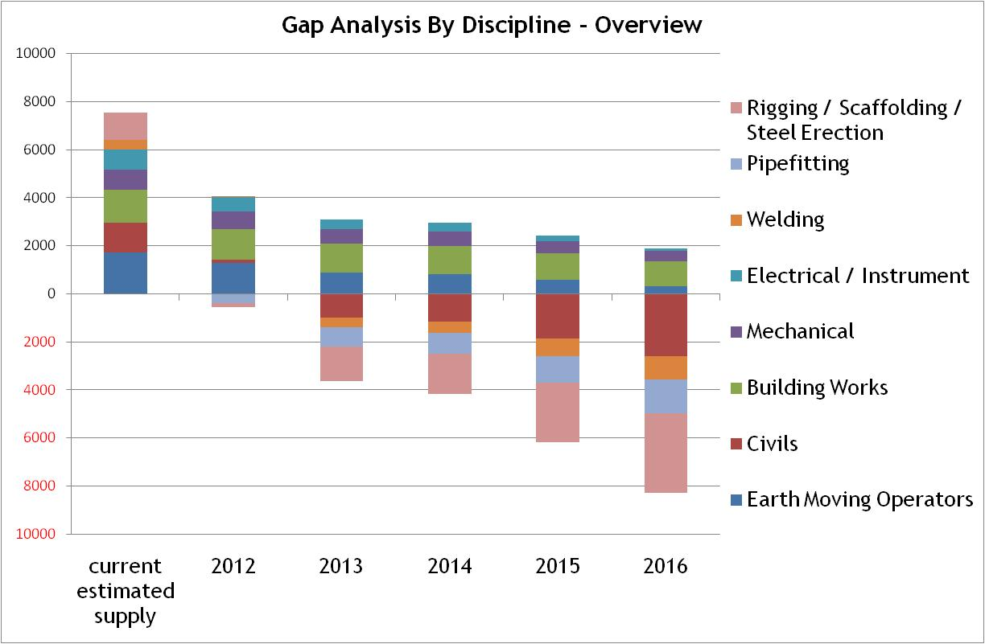

In November 2011, OPITO produced a report assessing the capacity of the Basrah Oil training Institute (BOTI) and the findings determined that there were significant barriers to the facility gaining international accreditation to a standard necessary for trainees to be employed with IOCs. UNDP also conducted a review of seven area training facilities and developed a matrix to evaluate the respective capacity of the facilities and to determine a vocational training centre as a candidate for refurbishment. The review revealed that dated infrastructure and limited resources have affected vocational training centers in the Basrah area (equipment and training) and that they would not be able to supply the number of labourers required or the quality of training necessary.

Based on the findings of the UNDP review, it was determined that a specified area of the Abu Al Khaseeb training centre would be rehabilitated and courses in the identified priority trades of scaffolding, rigging and welding would be developed. The refurbishment and improved governance of the selected section of Abu Al Khaseeb was intended to be a pilot project and a model for the rest of the institution, as well as for other area vocational training centres. In parallel to these activities a complete strategy and plan for the construction of a new vocational training centre in the area would be undertaken.

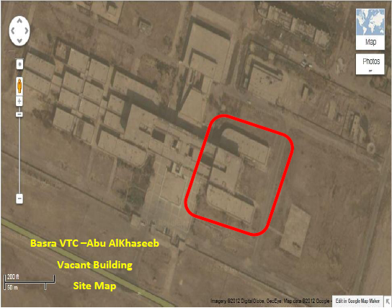

Abu Al Khaseeb is managed by the Ministry of Labour and Social Affairs (MOLSA). Hence UNDP and Shell engaged with MOLSA in a workshop in Amman on May 30th and 31st, 2012 to discuss the project objectives to establish a facility that would contribute to bridging the gap between demand and supply of a qualified work force for the growing oil and gas industry in Basrah for the crafts of welding, scaffolding and rigging, that would meet international standards and accreditation of the oil and gas industry. In addition, the envisaged concept would be based on sustainable financing model, and work with the oil and gas industry and Basrah-area contractors to ensure a high percentage of graduates are employed. In principle, all parties agreed to move forward, subject to available funds.

UNDP mobilized a field team and conducted research on welding, scaffolding, and rigging vocational training in the region, which resulted in the preparation of rehabilitation designs and cost estimates for Abu Al Khaseeb. UNDP also engaged in research of the key principles of vocational training in order that the training activities would follow internationally-known TVET principles that reflect relevance to the labour market, broad access for learners, quality delivery, standardization, inclusion of soft skills, and secure funding, as well as research on possible models for cost-sharing by additional IOCs.

Several IOCs were approached to propose a cost-sharing modality for the refurbishment of Abu Al Khaseeb and several demonstrated interest under the provision that they could be part of the Training, Technology and Scholarship Fund (TTSF) under SHELL service contract obligations (article 26) with the Iraqi Ministry of Oil.

A follow-up meeting was held with MOLSA in Baghdad in July 2012, at which UNDP was advised to prepare a Memorandum of Understanding (MoU) as the foundation and first step for UNDP-MOLSA partnership. UNDP submitted a draft MoU to MOLSA in August 2012. Unfortunately MOLSA was unable to sign the MOU and as of February 2013, despite extensive efforts by UNDP’s representatives in Baghdad to follow up on the issue, UNDP advised MOLSA that the funds that had been earmarked for this project by Shell and other IOCs were no longer available and had been reallocated to other initiatives. UNDP informed MOLSA that a detailed technical design for a partial rehabilitation of the Abu al-Khaseeb Vocational Training Centre that meets international oil and gas industry standards for vocational training had been prepared by UNDP engineers and would be shared with MOLSA for their own use.

At this point, UNDP intensified its engagement with the Ministry of Oil (MoO), with whom an MOU had been signed in November 2011 “*to establish a framework of collaboration that leads to the enhancement of the skills and capabilities of the labour force in Iraq, and the adoption of new technologies and advancement of research to meet international standards of the oil industry, and to creating knowledge spillovers conducive to incremental gains in the productivity of the whole energy sector.”* Under the umbrella partnership with MoO,UNDP thereafter initiated engagement with South Oil Company (SOC) and an MOU between the two parties was signed in September 2013, “*to co-operate to develop a Human Resources Strategic Plan that addresses gaps in the skills & capacities through training, technology and research with view to reach international standards as well as ensuring increased employment of Iraqi nationals in the oil and gas sector in Iraq.”*

Negotiations began between Shell, UNDP and SOC to determine the way forward. It was agreed that a new Welding Training & Test Centre be built for SOC staff. UNDP also required that unemployed youth be included in training at the new facility, in the intention of the original training centre, to fill the gap in the provision of local labour.

A steering committee was formed with representatives from all parties where discussions on the way forward took place. Once it was determined that a new building was required, UNDP prepared sketch designs and estimated costs, which were presented to Shell in October 2013.

In February, 2014, SOC and Shell, in partnership with UNDP, agreed to establish a new Welding Training and Test Centre at Burjesiyah, Basrah, Iraq to be financed with Training Technology and Scholarship Funds (TTSF) under Article 26 Obligation of the Service Contract Agreement signed by Shell and MoO.

Deliver Business Start-Up and Development Services to Entrepreneurs:

Capacity Building/ Training of Trainers

The project aimed to address the constraints experienced by the MSME sector and the lack of MSME support infrastructure in Basrah by targeting service gaps that prevent local businesses from effectively responding to the needs of the IOCs and their supply-chain partners. The project was intended to lead to the promotion of tangible outputs and outcomes relating to measurable increases in local businesses successfully bidding for service contracts with the IOCs operating in Basrah, increased business activity, the growth of existing enterprises, and increased levels of new jobs being created within the MSME sector.

Following an initial inception phase to gather information and assess the local needs in business development services in order to ensure relevance and sustainability of the interventions, the project was designed to be implemented in two phases, which would result in the establishment of a business incubation service (BIS), followed by a business incubation centre (BIC).

Thus the support offered to targeted MSMEs was the following:

* Promote local competitiveness amongst product/service providers through access to business support services that disseminate information on partnership requirements - trading standards, H&S procedures, etc.
* Provide support to potential MSMEs by running workshops on bidding and tendering for IOC contracts to change cultural approaches to working with IOCs and international product/service providers
* Facilitate development of MSME capacities through improved access to a range of existing advisory services within the Basrah Business Development Services (BDS) network

The initial stage involved mapping for the selection of existing BDS providers and the selection of individuals to participate in delivering business support to Basrah companies in a Training of Trainers program. One of the key findings was that former significant initiatives hosted at the Chamber of Commerce failed to demonstrate viability in the absence of external funding. The lesson learned was that these initiatives were donor-driven and were not set up from the outset as viable, self-sustaining businesses.

Therefore, the project approach was revised in order to avoid the same challenges and it was agreed to proceed by incremental steps, starting with endeavouring to better understand the market demands and willingness to pay for training and business development services. At the same time, the project began developing a cadre of trainers to fulfill these needs in the local market.

To this end, 121 applications were received, 105 approved, and 97 trainees completed the training that took place in September and October 2012. During the training, there was a second step in the selection in order to nominate the best candidates from among the trainers to advance to the second stage of capacity building. The company undertaking the training developed an in-class selection criteria that was applied to all participants, and 16 of these trainers were selected to continue in the program in November 2012.

Following that initial selection by the trainers, issues such as availability and overall suitability were also taken into account, thus, expanded the parameters of the selection and applied a holistic approach to the selection to narrow down the selection of top candidates and ensure the most proper and sustainable selection of candidates. This filter was based on numeric values to the following parameters:

* Test score in the initial training
* Availability
* Work experience
* Major and field of education

Each category was worth 25% and the total in each case was out of 1. Another acceptance filter was added regarding employment in the public sector. These employees were automatically excluded Interviews and further selection of trainers took place in December 2012 and 14 trainers were retained.

Those trainers began to deliver a series of training sessions to companies that had expressed interest in order to develop a better understanding of market demand and range of skills, needs and priorities from the private sector in Basrah. The first session the trainers participated in was a Shell prequalification training in January 2013, after which the number of trainers was reduced to 11 based on further performance evaluation.

After applying the third selection criteria to select the candidates, an interview guide was prepared and another interview committee was set up composed on UNDP project representative, a member of the steering committee, an unaffiliated university professor, and for HS&E and Contract management, two engineers with technical experience in the field were included in the proceedings. In most cases, the selected candidates were confirmed, and in one case, the candidate was replaced with another more suitable for the requirements (contract management). The interviews resulted in selection of:

* HS&E: 4 selected
* Contract management: 2 selected
* Procurement: 4 selected
* Entrepreneurship: 3 selected

The second phase proceeded with the top trainers who were enrolled in relevant courses to obtain international certification and practical experience, to be followed by the third level of screening, which was the examination stage of the certified training. This selection processes was meant to verify and sculpt the trainees into becoming professional trainers and consultants in their own right able to deliver the needed services to Basrah companies independent or with little help from outside enablers such as the UNDP.

The five categories of businesses that would be likely candidates for BIS support included those enterprises that are:

* 1. Established in business and providing services to IOCs and supply-chain actors in the oil sector
  2. Established in business, but not providing services to IOCs and oil industry supply-chain providers
  3. Providing a business service, but as an unregistered enterprise activity (possibly through informal sub-contracting relationships)
  4. Providing a stated business service (in a formal or informal corporate capacity), but possessing transferable skills and experience that could be utilized to develop a new service strand to respond to business opportunities
  5. Possessing a business idea and/or skills, but not currently providing a formal business service in the local economy

The project envisioned that the capacity of the trainers would be developed in areas of expertise relevant to market demands would be progressively equipped to deliver a range of services, comprising of some of the following:

* Business Idea Generation support to young entrepreneurs, women and individuals and groups with special needs
* Business counseling, advisory and mentoring support
* Training services in management skills covering pre-start to growth and export activity
* Business and financial planning support (inc. funding and investment support)
* Assistance with regulatory compliance and registration
* Marketing and market research support to businesses
* Business information services
* Business mentoring and awareness raising of international standards and international approaches to doing business (inc. business etiquette/presentation skills)
* On-site BDS that would include, bookkeeping, legal assistance, access to innovation and patenting services, etc
* Access to networks of business support: introductions to other pro-business organizations which will promote B2B opportunities and help sustain the on-going development of enterprises using the BIS-BIC (inc. integration into local supply-chains)
* Access to the infrastructure typically associated with BICs (e.g. reliable utilities support for the operation of a business including electricity, water, IT/telecommunications, business secretarial services, secure workspace premises and customer facilities on a tenant sharing basis)
* Mentoring and planning support for life after exit from the BIC and entry into the wider Basrah real estate marketplace once financially viability in a given business has been proven; typically within a two to three year period of receiving initial BIS/BIC support.

Once the recruitment process for trainers was complete, the project considered that these individuals could become entrepreneurs and offer relevant BIS in Basrah. To this end, UNDP assisted them in considering various business models, legal statuses and governance structures, and discussed the level of interest and commitment of each individual to proceed as a group or individually. UNDP invested in these individuals further through sponsorship of their participation in accredited courses and the arrangement of apprenticeships. After considering the amount of work and anticipated obstacles for the trainers in setting up their own businesses, and the level of risk and uncertainty that they would have to accept, it became clear to them that other options were going to be more viable, namely, applying to IOCs and large corporations, or remaining employees under the project, both of which offered relative levels of security. As a result, either because of the lack of demonstrated aptitude or personal choice, none of the individuals committed to starting their own businesses offering BIS, but rather they chose to use the skills obtained in the process to seek employment with an existing company or were separated from the project. The aim of the project was to create independent, sustainable development service providers in Basrah and not to contribute to an environment of additional unsustainable, donor-driven employment opportunities.

In line with Shell’s commitment to providing local content, they produced a list of required services for local companies to bid on. UNDP’s role was to identify relevant local companies, or individuals willing and capable to start up a new company, with the potential to fulfill a number of the selected services, which included Majnoon Perimeter Wall Paintings/Decoration, Majnoon Litter Collection, a Driving School, and Bus Service Companies to Basrah/Majnoon/Villages.

An initial challenge was the time required to identify potential service providers and prepare them to bid for the contracts, particularly for start-up companies, while the procurement schedule of Shell was inflexible. In addition, the process did not draw upon the qualities of entrepreneurship necessary for individuals to successfully take risks and ownership of the new businesses. These factors, along with additional changes in the scope of several of the contracts, became obstacles for the identified companies and individuals to complete the necessary preparations and compete for the contracts.

At this point, it was decided by UNDP to no longer support the start-up of small companies, but only micro-businesses under the LADP process. It was also decided to focus future training on a select group of medium companies and to launch an independent assessment of their needs.

In the case of the driving school, an innovative model was pursued, involving UNDP in a limited oversight role, a financing institution, and an international company already providing driving training, would agree to partner with a local start-up company. In this particular instance, a disagreement over who would eventually control the new local company resulted in the project becoming unable to attain the anticipated objectives, at which time UNDP withdrew from the project and Shell and the financial institution continued to consider potential avenues of cooperation on the project.

The Majnoon Perimeter Wall Painting project to beautify the security T-Wall surrounding the Majnoon area was completed in June 2013. UNDP identified local artists and asked them to submit paintings to be considered for inclusion in the project. A total of 8 paintings by 4 artists (2 paintings each) were selected to be scanned, reproduced on a large scale, and placed along the exterior of the T-Walls surrounding the Majnoon complex perimeter.

|  |  |
| --- | --- |
| IMG_0006.JPG | C:\Documents and Settings\Nillanj\Desktop\MSME Photos painting\Abdulmalik Ashour(2).jpg |
| E:\MSME Photos painting\Abd Al Radha (2).jpgC:\Documents and Settings\Nillanj\Desktop\MSME Photos painting\Issa Abdullah (2).jpg | E:\MSME Photos painting\Abd Al Radha(1) .jpg |
| C:\Documents and Settings\Nillanj\Desktop\MSME Photos painting\Issa Abdullah (1).jpg | C:\Documents and Settings\Nillanj\Desktop\MSME Photos painting\Sabry Almalky(2).jpg |

Capacity Building for Potential Oil & Gas Supply Chain Contractors

The project targeted the MSME service gaps that prevent local businesses from being equipped to respond to the needs of IOCs and their supply-chain partners in Basrah due to a lack of competitiveness, a lack of appropriate service provision, and/or a lack of capacity to address international standards in doing business. The project aimed to build the capacities of local enterprises and entrepreneurs to respond to the growing number of supply-chain opportunities tied to increased IOC activity in Southern Iraq. The development of the capacity of the MSME sector to respond to new opportunities in a competitive way will not only meet short-term needs linked to the strategic oil sector’s requirements, but ultimately support the need to diversify Iraq’s MSMEs economy.

The project was initiated with engagement in multi-stakeholder dialogue, and a sub-steering committee was formed and held meetings on 9 September and 23 October, 2012, where the strategic objectives and project road map were determined:

* Identification of select group of medium enterprises that had expressed interest in diversification and expansion to respond to oil and gas industry demands
* Immediate support given to SMEs based on identified urgent needs e.g. procurement, proposal writing training, safety etc.

UNDP put a call out to interested MSMEs through advertisements on local radio and information posters, inviting them to participate in capacity building workshops and activities in pre-qualification, bidding, health and safety, project management, and entrepreneurship. Meetings took place with interested companies in August, September, November and December 2012 to determine needs and discuss the way forward. The selection of the companies who wished to participate and work with Shell was completed in November 2012.

On January 26th to 30th, 2013, 23 local companies (comprising of 44 representatives) attended pre-qualification training, 18 of which enrolled specifically to build their capacity to prequalify for Shell contracts.

Capacity Building for Shell Existing Contractors

In May 2013 Shell provided UNDP with a list of 34 local contractors who had successfully completed contracts for Shell in Basrah. This included 24 small contractors and 10 medium and large contractors. At this stage, it was determined that the Shell existing contractors would be the focus of the capacity building efforts under the MSME component in order to experiment the approach before considering scaling up the initiative.

A comprehensive capacity assessment of Shell existing contractors was thus conducted by UNDP in June 2013 through the design of an initial diagnostic survey questionnaire that was completed by 26 participating contractors to assess their strengths and needs. An analysis report identified the shared shortcomings among the contractors, which were used to prepare a training road map based on priority intervention areas.

A series of three workshops were conducted with the contractors on September 16th, 17th, and 19th, 2013 for feedback on the findings of the report and to discuss the way forward. Preliminary training sessions were delivered on identified priority topics, such as HSE, ISO 9001, English Language, Contract Management, Project Management, Supply Chain Management, Strategic Planning, Asset Management and the 5Ss system on October 2013.

# Challenges & Lessons Learned

### Challenges of the Shell-UNDP Partnership

The non-traditional partnership established between UNDP and Shell has grown into a productive relationship. As UNDP and Shell have different ways of working, there have been initial challenges in determining the most effective ways to accomplish the strategic objectives of each organization and the most efficient use of resources within the within the partnership.

One of the main challenges has been to be reaching an agreed definition on the results expected from Shell’s investment, how these should be measured, and how this constitutes value for money. It has been challenging to reach consensus in defining measurable results for intangible outcomes such as community empowerment and social cohesion that are meaningful to Shell’s corporate leadership. Short video documentaries have been used to complement standard progress reporting to convey the essence of project results to the different tiers within Shell’s management structure.

Another challenge is the sustainability of the partnership and the ability of both parties to institutionalize the knowledge gained through the initiation and process of implementing the partnership in a way that it will survive turnover of the initial individuals involved. The partnership has been enhanced by the involvement of individuals whose experience bridges across the private sector and development worlds and who are able to understand the perspectives and drivers of both partner organizations, but both Shell and UNDP must ensure that ways of working that have been established over the course of the partnership to date and the spirit of partnership remain.

Shell and UNDP worked together to address this challenge by documenting processes and systematizing procedures, which has included the creation of a detailed Operations Manual, establishment of a reporting structure, defining frequency of the exchange of information, recording decisions and achievements, and maintaining a focus on capturing results. As a result, Shell and UNDP began working more as a team, contributing collectively with shared accountability,

The partnership with Shell is a much more active partnership than that with traditional donors. Shell does not limit its involvement to simple financing of agreed activities but seeks to be an active co-creator of interventions that meet their strategic and operational goals. This requires the development of partnership mechanisms that support integrated team work and joint decision.

### Operational Challenges

The lack of flexibility in UNDP’s administrative and operating system has at times hindered the ability to adapt quickly to evolving circumstances and meet Shell’s high expectations of quick progress and flexible implementation. In addition, security restrictions severely limit the mobility of UNDP staff in the field, affecting the ability to directly manage and monitor projects. Long Term Service Agreements have been used to enable third party companies to deploy individual specialists, and tailor-made teams to operate on the ground. These modalities permit UNDP to remotely manage project activities but allow increased flexibility to respond to Shell’s needs for delivery on the ground.

### LADP Challenges

A challenge has been how to ensure coordination, alignment and harmonization of the LADP process with Majnoon Shell social investment activities. This includes finding synergy and overlap in the messages delivered by both parties, ways of working, expectations of communities, how priorities are identified, how UNDP’s previous success and failures affect Shell and vice versa. The solution to this challenge requires determining the definition of a shared vision for the most complementary version of the attainment of the goals of the UNDP model and those of the Shell social investment activities, with clarity on how to integrate approaches and concepts and discussions on how these will evolve over time.

The activation of the village representative network and the ability of UNDP to institutionalize a process beyond the local administrative authority was a challenge for the LADP process. The process requires credibility at the village level in order that information gathered by the village representative network feeds into the local council gains legitimacy. UNDP understands the necessity to work with official structures and create space for the participatory process to work and identify connections within existing systems, which requires building the capacity of those structures.

The community in Al Nashwah refused training package offered by UNDP as they did not see the material as relevant to their needs. UNDP recognizes the lesson learned that we need to invest more time and effort to articulate our vision of a community-led development process and mechanism and coach the villagers accordingly. UNDP recognizes that for the village representative network to drive the LADP process and confront resistance to change by traditional structures, the individuals must understand the long term goals of the process and recognize their interest in joining in as a prerequisite for them to buy in. This requires that UNDP invests in the network and gives them legitimacy by transferring the knowledge and skills required for them to fulfill their role effectively. Moving forward, UNDP will hire an experienced Community Development Specialist to lead the process.

The challenge of the LADP process in Al Dair specifically was that UNDP was not authorized to go to each village because of perceived disappointing past experiences with Shell, and a fear of raising expectations in communities. The LADP team was cautious to agree to the approach suggested by the local council, which dealt solely with the local elites, because of risks that lack of inclusiveness may translate into poor transparency and accountability to the entire community. As a key principle of LADP, inclusiveness of all to determine most important needs and priorities and ensuing resource allocation is key in avoiding elite control and capture of resources and possible discrimination and inequalities.

In Al Dair, UNDP is now addressing this issue in part though the preparation of a five-year municipal plan as requested by the Al Dair local representatives, which will be formulated in an inclusive and participatory manner through genuine dialogue on needs and priorities with constituency.

UNDP has demonstrated its capacity to sustain relationships and maintain a dialogue with groups who have temporarily suspended their interaction with Shell, and act as an effective broker and an interface amongst different groups, including government at different levels, communities, and private sector.

### VT/MSME Challenges

The ability to identify the right centre and right partner as part of the vocational training programme was a challenge for UNDP and Shell. While MOLSA was initially identified as the management for Abu Al Khaseeb and the best partner, MOLSA was unable to sign an MOU with UNDP due to exhaustive bureaucracy and the inability for IOCs to fund the project with Article 26 funds, which have to be spent under the management of MoO.

In response to the above challenge, UNDP formed a partnership and signed an MOU with SOC, however partnering with the public sector on the vocational training centre project continued to be a challenge because the GoI is heavily centralized and the project required that the vocational training centre be relevant to requirements of Basrah.

A lesson learned through the process of engaging with SOC and MoO regarding soft skills training is that the over-staffed public sector requires significant reforms, including merit-based and effective management.

# Financial Section[[2]](#footnote-2)

## LADP Financial Summary

|  |  |  |  |  |  |  |  |  |
| --- | --- | --- | --- | --- | --- | --- | --- | --- |
|  | **Yr 1 (2012 – 2013)** | | **Yr 2 (2013 – 2014)** | | **Yr 3 (2014 – 2015)** | | ***Yr 4 (2015 – 2016)*** | |
| Planned Budget US$ | 1,127,875 | | 2,076,840 | | 1,510,000 | | *Expected TBD* | |
| Amount Committed/Spent US$ | 205,999 | | 1,846,840 | | TBD | | TBD | |
| Amount Carried Over US$ | *921,876* | | *230,000* | | *TBD* | | TBD | |
| Additional Funds Required For Following Year  US$ | *1,328,124* | | *1,280,000* | |  | |  | |
| Activities Completed | *Governance structures* | *42,200* | Community consultation & Need Assessment | *74,000* | *Training unemployed youth-* 2013 start | *170,000* | *Micro-business* | *400,000* |
| *Baseline survey* | *72,000* | *Rehab 2 schools* | *750,000* | *Municipal Plan & Asset Mgt.* | *200,000* | *Municipal Asset Mgt.* | *70,000* |
| *Community need assessments* | *72,000* | *Media coverage* | *50,000* | *Rehab school* | *400,000* | *Farmers Fair & agricultural projects* | *90,000* |
| *Prioritization& Project selection* | *19,799* | *Village Rep training & Network* | *100,000* | *Independent Evaluation* | *50,000* | *VTC feasibility study* | *100,000* |
|  |  | *Micro-business* | *330,000* | *Agriculture Study* | *50,000* |  |  |
|  |  |  |  | *4 playgrounds* | *240,000* |  |  |

## VT/MSME Financial Summary

|  |  |  |  |  |  |  |  |  |  |
| --- | --- | --- | --- | --- | --- | --- | --- | --- | --- |
|  | **Yr 1 (2012 – 2013)** | | **Yr 2 (2013 – 2014)** | | **Yr 3 (2014 – 2015)** | | ***Yr 4 (2015 – 2016)*** | | |
| Planned Budget US$ | 1,394,586 | | 1,591,564 | | 1,681,050 | | Expected | | |
| Amount Committed/Spent US$ | 605,240 | | 1,105,275 | | TBD | |  | | |
| Amount Carried Over US$ | 789,346 | | 486,289 | | TBD | |  | | |
| Additional Funds Required For Following Year  US$ | 802,218 | | 1,194,761 | |  | |  | | |
| Activities Completed | *VTC tech. & training designs* | *184,054* | *MoO & SOC MoUs* | *28,900* | *Negotiations with MoO/SOC* | *10,000* |  |  | |
|  | *MSME training and TOT* | *421,186* | *Welding Ctre tech. & train.g designs* | *70,500* | *Capacity Building of Contractors* | *1,190,750* |  |  | |
|  |  |  | *Contractors Assest.&train.* | *177,200* |  |  |  |  | |
|  |  |  | *Majnoon Landscaping & paintings* | *36,400* |  | | | | |
|  |  |  | *Training facilities& TOT* | *98,100* |  |  |  | |  |

## Welding Training and Test Centre Financial Summary

|  |  |  |  |  |  |  |
| --- | --- | --- | --- | --- | --- | --- |
|  | **Yr 3 (2014 – 2015)** | | **Yr 4 (2015 – 2016)** | | **Yr 5 (2016 – 2017)** | |
| Planned Budget US$ | 11,000,000 | | 5,665,000 | |  | |
| Activity Budget | *WTTC* | *5,700,000* |  | 3,000,000 |  |  |
|  | *Infrastructure*\* | *5,300,000* |  | *2,665,000* |  |  |
| *\* Additional infrastructure package requested by SOC – cost estimation and negotiation in progress – final approval pending - breakdown per year tentative* | | |  |  |  |  |

## Annex A – Priority Needs List

### Empty Form

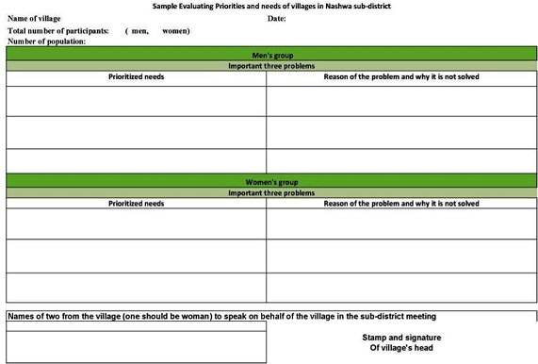

### Complete Form

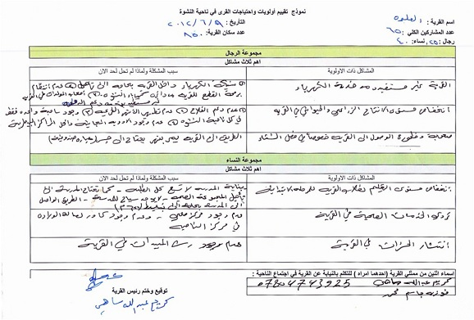

## Annex B

### Hand-drawn Village Map

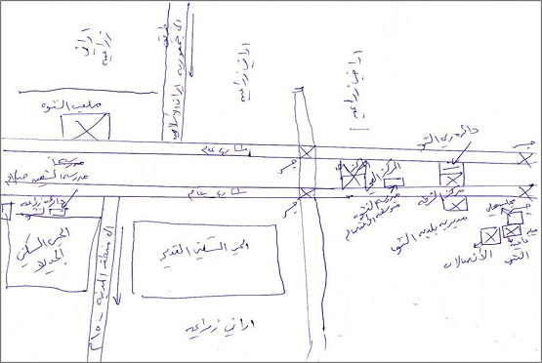

## Annex C

### Needs and Priorities Identified in Participatory Process (by village)

|  |  |  |  |  |  |  |  |  |
| --- | --- | --- | --- | --- | --- | --- | --- | --- |
| **No.** | **Date** | **Village** | **Attendance** | | **Female Representative Elected** | **Village Map produced** | **Village Tour conducted** | **Comments and most important needs** |
| **Male** | **Female** |
| **1** | 5-May-12 | Al-Dowa | 55 | 50 | Soha Attya Abdul-Ridha | not Done | not done | **Impression of the participants at Shell :** reactions of participants were very negative about the performance of Shell as well as the Municipal Council in particular with regard to services provided by Shell for the village.  **most common need :**Difficult of obtaining medications in cases of emergency and deliveries Special cases of urgent deliveries. |
| **2** | 6-May-12 | Al-Radhiya | 24 | 30 | Seeham Mardan | done | done | **most common need:** Lack of simplest health services in the village especially in cases of emergency and deliveries. **Impression of the participants at Shel**l the attendance Blame Shell to employ a small number of unemployed people in the village they said that : there is Lack of justice to employ unemployed |
| **3** | 14-May-12 | Northern Al-Khaliliya village- | 35 | 21 | Na'eema Jawad | done | done | **most common need**: Lack of health services in the village |
| **4** | 15-May-12 | Al-Dhuwa'in | 48 | 42 | Salwa Jawad Kadhum | done | done | **Impression of the participants at Shell :**  1 - the problem of land confiscated some farmers without compensation for their land  2 - the problem of air pollution because of the smoke issued from the work of Shell and not covered by the electricity line linking the oil.  **most common need:** Lack of health services provided to women |
| **5** | 16-May-12 | Bait Hnayan- | 25 | 15 | Waheeda Salih | done | done | **Impression of the participants at Shell :** reactions of participants were very negative about the performance of Shell For two main reasons (1)Shell did not hire the unemployed in the village (2)Shell caused major damage to the main road of the village  **most common need: (1**)Repairing the main road to the village in addition to the difficulty of using the internal roads of the village**(2)**  Lack of health services in the village |
| **6** | 20-May-12 | Al-Shahban- | 30 | 55 | Zahrah Makhakh | done | done | **significant story :** The presence of a senior cleric in Al-Nashwa district, he is one of the inhabitants of the village, to the meeting great effect in directing the attention of participants to the importance of this activity as he may understand much idea of the project and praised them and this will have an impact actor in contact representatives of the village with the phases of the program.  **most common need:** Lack of birth lounge neither in the village nor in the neighboring territories. |
| **7** | 23-May-12 | Bani Skain- | 25 | 40 | No Female representative elected | done | done | **Impression of the participants at Shell** : Participants in the meeting were very satisfied with the performance of the Shell and the team noted the existence of services provided to residents of the village by Shell such as repairing roads and send to the village health staff.  **significant story** :female participants in the meeting rejected to nominate any of them  **most common need:** There is a building in the village for the health clinic has been canceled by an official from the Department of Health Basra is now abandoned |
| **8** | 26-May-12 | Center village- | 45 | 30 | Haniya Ghadhban Hatif | done | done | **significant story:** - A woman was nominated after consulting her husband who considers himself as her escort in future meetings.  **most common need:**  Abundance of deaths at birth of children and Entity of birth lounge but none existing of specialized cadre in the health center. |
| **9** | 28-May-12 | Al-Mafati - | 19 | 17 | Hamdiya Ismail | done | done | **most common need:** Lack of health services in the village as well as Difficulty of completion intermediate study for boys. |
| **10** | 30-May-12 | Abu Gharab- | 30 | 30 | Hadiya Salih | done | done | **significant story:** an altercation between the women at the meeting at the stage of the nominate a representative of the village in the district committee, this is the only village with a high competition for the post of representative of the village, And finally one of the female participant have been nominated.  **most common need:** Lack of health services provided to women |
| **11** | 3-Jun-12 | AL Baijiyah | 15 | 10 | Wafaa Abbas Muhamad | done | done | **most priority needs:**  - deterioration of education for children in the village of age (6-12) years, Because there is no school in the village and Current school is far from the village (5 km) - Lack of simplest health services in the village especially in cases of emergency and deliveries. **significant story**  : The village had set up the banquet lunch for one of the top officials in Shell during the ninth month of last year Which affected positively in the opinion of the people in the village on the activity of Shell |
| **12** | 4-Jun-12 | Albu Mchih | 20 | 20 | Attiya Escandar | done | done | **most priority needs:**  - deterioration of the educational and health service provided to students in the elementary school in the village.  **significant story :**There is a significant sporting activity in the village and there are 15 sport team recognized by the sport department of the Governorate and there is no playland sport in the village. |
| **13** | 6-Jun-12 | AL Lafiyah | 26 | 15 | Moza Abd | done | done | Significant Story: Village youth dropped down their request after insisting on adding it to the list of priorities, the village leader convinced them that the land in the Village are owned to individuals and no farmer will allow to give up his land to be used as Play ground.  Most important need: the spread of flying insects are the most important problem that the participants concentrated on, this problem will cause health diseases and specially on summer season, knowing that the village has a lot of farms and also adjacent to the main river of the Sub-district |
| **14** | 7-Jun-12 | Albu Busayri | 35 | 30 | Sitah Abd Al A`amah | done | done | Significant Story: when the male participants completed prioritizing their problems, they were very eager to know the problems that females agreed on, after reading it, all male Participants liked the quality of female prioritized problems. MIP: shortage of water due to insufficient capacity of the existing WTP and the inappropriate location of it (suffers from drought in summer season), also there is a need to install more pipes to the existing network to cover all houses. |
| **15** | 9-Jun-12 | Al Alwa | 25 | 40 | Fauziyah Jasim | done | done | **Participant’s opinion on Shell:** all participants are convinced of the mechanism used by Shell for hiring the unemployed males in the village, but they were surprised that when unemployed people comes from another village and they are rejected, the company doesn’t compensate from our village knowing that the nomination from the village is done through voting. **Most Important need:** villagers doesn’t make use of the existing Electricity Network and also Generator Owners doesn’t make use of the Government support by supplying Fuel. |
| **16** | 9-Jun-12 | Albu Diflah | 25 | 25 | Ma`asooma Awad | done | done | **Significant story:** village participants are convinced that their village is small and located between many big villages that have basic services such as schools, so they are welcoming the idea of developing services in those villages in order to benefit from it in the future.  **Most Important need**: Villagers complained that and even if their main road to the village is paved, but it is difficult to travel inside the village because the inner lanes are not paved |
| **17** | 12-Jun-12 | Kut Alkhan | 32 | 15 | Eman Kadhim ali | done | done | **Significant story:** For the first time the participants of men and women agreed on problems within the same priority, noting that the meeting place of posts of women is far from the site meeting of men. But the team explained that because of the spread of the culture of meetings and meetings outputs between the people of the villages where the participants become not to direct any question about the program as it was occurring in the first meetings. **Most Important need:** The most prominent of what was agreed upon by the participants of the priority problems is the scarcity of water supply because of the farness of the village from the main water treatment plant as well as subscription of five other villages in this project in addition to the lack of the amount of discharged water for the village. As participants noted that the power outages for water project is one of the main reasons for water scarcity as the program of cutting power is not compatible between the village and the water project.  Regards |
| **18** | 17-Jun-12 | Bait Hazaa | 15 | 12 | Rabbab Muhamad Salih | done | done | **Most Important need**: Due to the fact that the village is agricultural, in the first place, participants in the meeting confirmed the importance of providing support to agriculture in the village through the provision of irrigation water as the peasants in the village are suffering from deterioration of agricultural production because of the difficulty of irrigating agricultural land  **Participant’s opinion on Shell:** BDS team noted that the meeting participants have confidence in the ability of Shell Company to solve most of the problems provided especially small projects which have public beneficial where participants asked the Chairman of the Local Council to address Shell Company for establishing a crossing on one of the rivers in the village instead of the current crossing as it is very dangerous, |
| **19** | 17-Jun-12 | AL Hawafith | 30 | 10 | No Female representative elected | done | done | **Most Important need:** The people of Al-Huwafidh village is suffering from a large scarcity in water supply where the current water treatment project is small and located at the end of the sub river in the village as there is no any filtering process neither purification of water before discharging it to the locals.   **Participant’s opinion on Shell:** During the meeting, a proposal submitted that Shell Company to contribute in pest control in the villages of district, this proposal can be done easily by Shell and that will have strong Impact on the lives of residents in of villages. |
| **20** | 19-Jun-12 | Ali Noor | 40 | 15 | Ameena Farhan Ahmad | done | done | **Priority problem:** female participants insisted on the importance of completing the secondary study for girls in the village, most girls stops at the intermediate stage due to the absence of any secondary school, the nearest one is about 2 Km far from the village. **Opinion on Shell:** BDS team noticed that female representatives were more critical from males about Shell company’s performance in unemployment issue and also service delivery, and the asked to convey a message that village citizens will demonstrate against the Company, male participants were very surprised and resented and refused that females mention this issue. |
| **21** | 19-Jun-12 | AL Midaniyah | 30 | 40 | Swad Hameed Sebir | done | done | **Priority Problems:** although the project of rehabilitating the existing electricity network of the village was submitted through the electricity directorate, the participants insisted that the quality of the network is bad due to the delay of implementing for more than one year.  **Significant story:** when BDS female team representative asked for nominating a female representative from the village, all females refused to nominate, but a male representative came to them and convinced them about the necessity of nominating a female and he will handle the transportation of the female when meetings are required. |

1. SHELL Annual Report 2012 p47 [↑](#footnote-ref-1)
2. These financial figures are interim and uncertified, pending the closure of semi-annual books . [↑](#footnote-ref-2)